https://www.jdoodle.com/embed/v0/5PRt
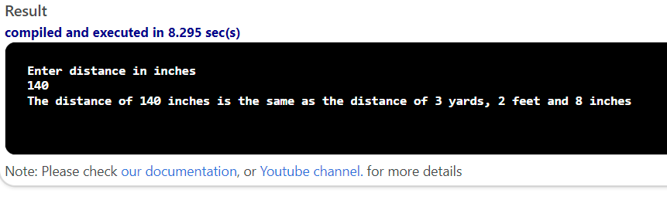

#include <iostream>

using namespace std;

int main()
{
int userInches, inches, feet, yards;

cout << "Enter distance in inches" << endl;
cin >> userInches; // assume user enters 50
inches=userInches;
feet = inches/12;
inches = inches%12; //This computes the remainder. So, inches is now 2 (the remainder). Quotient is ignored.
yards = feet / 3; //This integer division computes quotient. So, yards is now 1 (the quotient).
//Find the remaining feet (from the feet above) by using remainder operator (%).
feet = feet % 3; //This computes the remainder. So, feet is now 1 (the remainder). Quotient is ignored.
cout<<"The distance of "<< userInches << " inches is the same as the distance of " << yards << " yards, "<< feet << " feet and "<< inches << " inches" << endl;
return 0;
}

